DATABASE CLASS-WORK

NAME: U. CHINEMEREM

1. create a report that displays the amount spent by each customer on each item displaying date, id of
sale and of customer names and amount spent:

ANS:

QUERY:

-- USE qacs_ch02;

Select SALE.SaleID, Total AS AmountSpent, FirstName, LastName, SaleDate AS Date
from CUSTOMER, SALE
where CUSTOMER.CustomerID = SALE.CustomerID
ORDER BY AmountSpent DESC;

IMAGE:

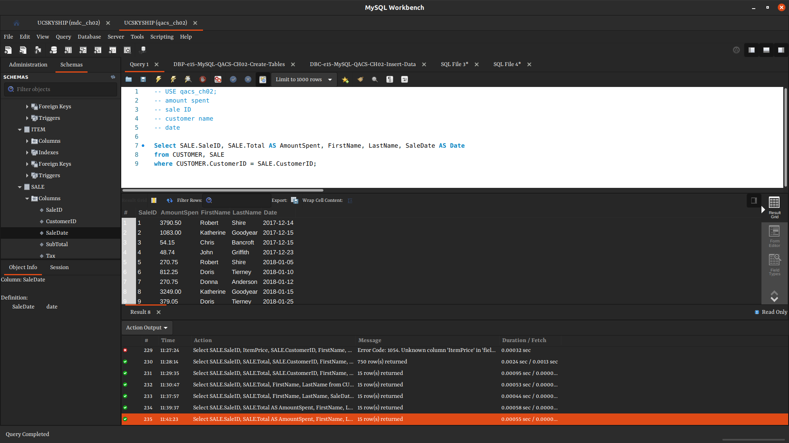

2. create a report to show the total amount each customer spent in our store, ** customer names,
total amount spent alongside id of both customer and sales are needed for the report

ANS:

QUERY:

-- USE qacs_ch02;

Select SUM(Total) AS AmountSpent, FirstName, LastName, CUSTOMER.CustomerID, SALE.SaleID
From SALE, CUSTOMER
Where SALE.CustomerID = CUSTOMER.CustomerID
GROUP BY CUSTOMER.CustomerID
ORDER BY Total DESC;

IMAGE:

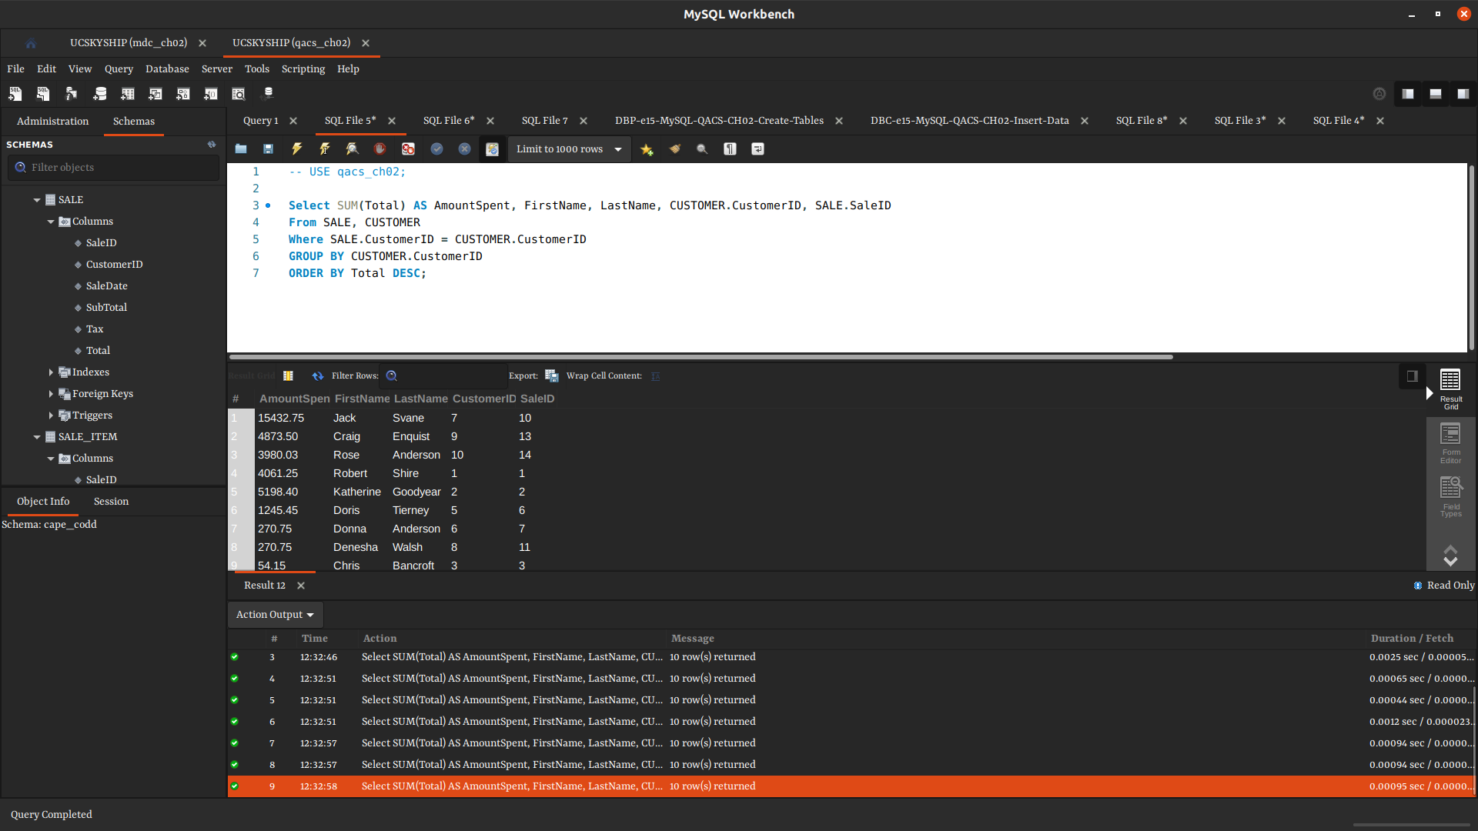

3. display the total amount we made in the store

ANS:

QUERY:

Select Sum(Total) AS TOTAL
From SALE;
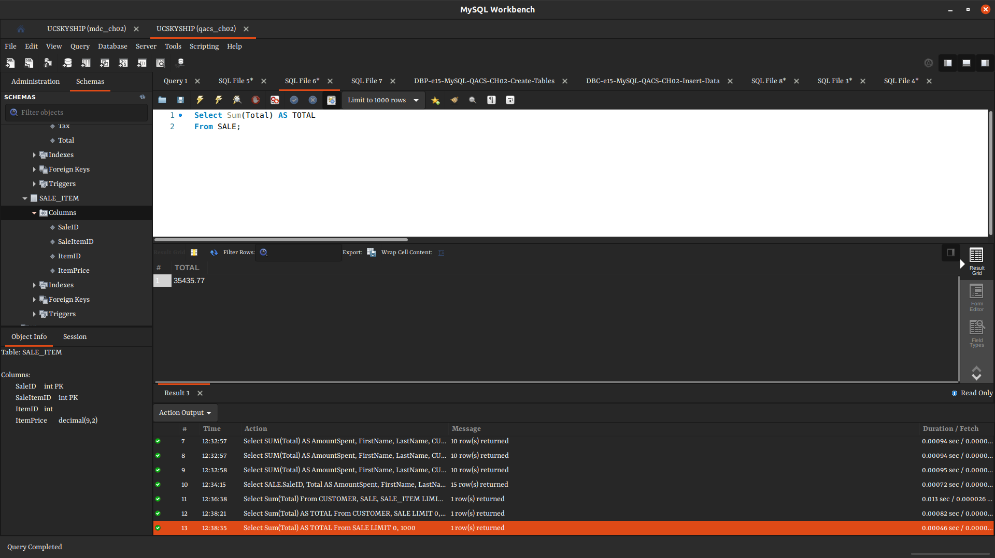

IMAGE:

4. create a report on items in the qac_cho02 database, show item price, sale Item id item description
and company name

ANS:

QUERY:

Select ITEM.ItemPrice, SaleItemID, ItemDescription, CompanyName
From ITEM, SALE_ITEM
WHERE SALE_ITEM.ItemID = ITEM.ItemID
ORDER BY ItemPrice DESC;

IMAGE:

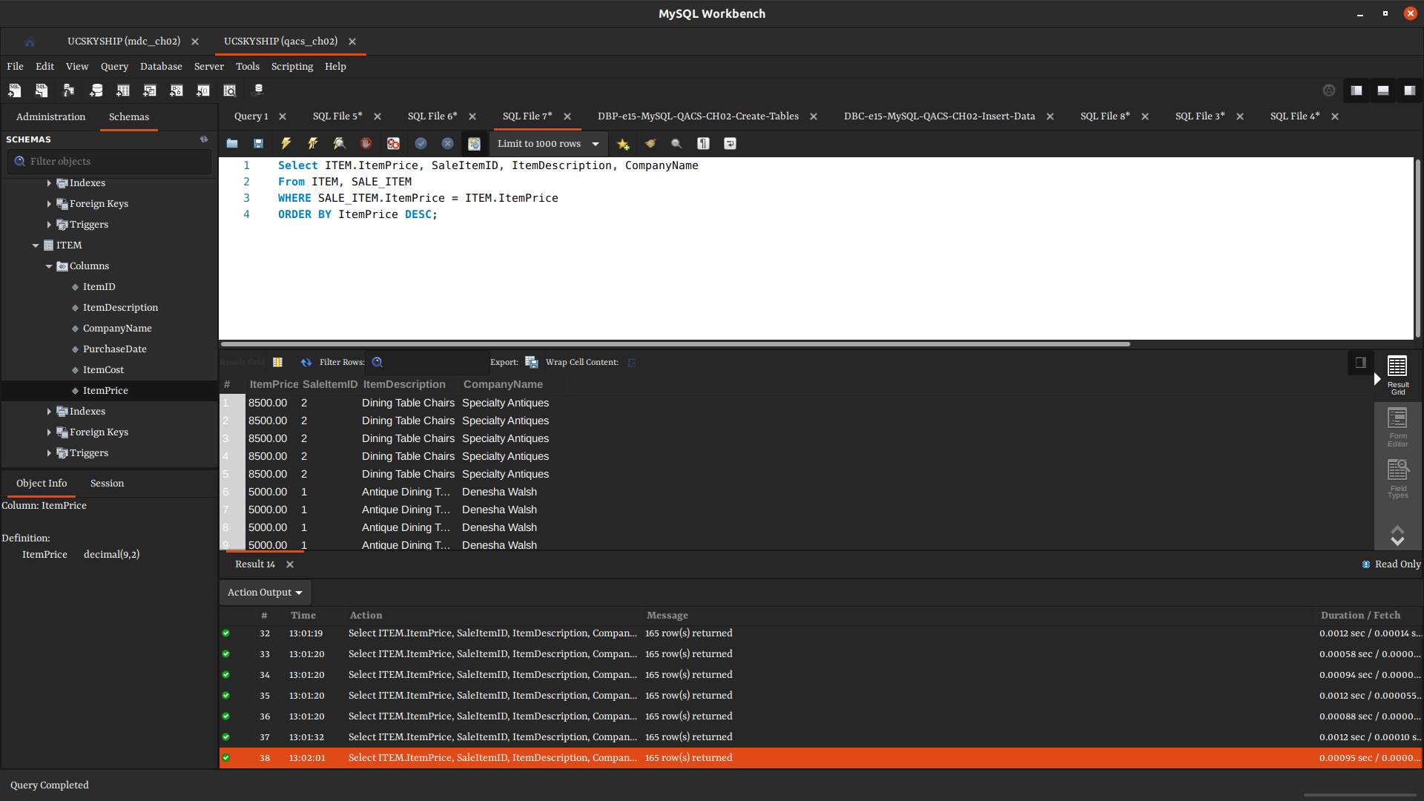

5. - create a report on items in the qac_cho02 database, display total amount for each sales item id
** show item price, sale Item id item description and company name

ANS:

QUERY:

Select SALE_ITEM.SaleItemID, SUM(ITEM.ItemPrice) AS TotalAmount, ItemDescription, CompanyName
From SALE_ITEM, ITEM
Where SALE_ITEM.ItemID = ITEM.ItemID
GROUP BY SaleItemID
ORDER BY TotalAmount DESC;

IMAGE:

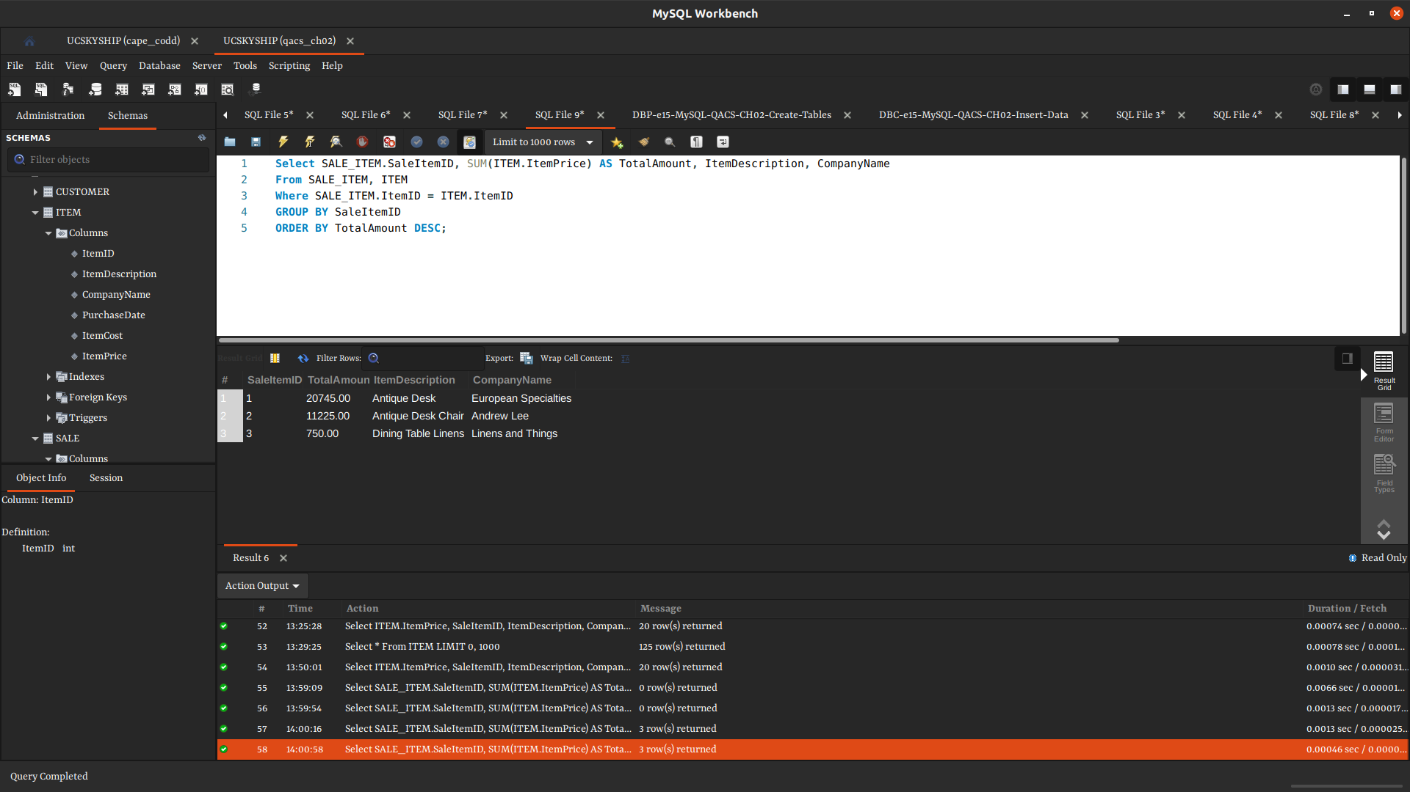

6. display customer name, item purchased by customer which is an artist work and the amount paid
for the work

ANS:

-- create database vrg;
-- USE vrg;
Select FirstName, LastName, Title AS ItemPurchased, SalesPrice AS AmountPaid
From CUSTOMER, WORK, TRANS
Where CUSTOMER.CustomerID = TRANS.CustomerID
AND WORK.WorkID = TRANS.WorkID
ORDER BY AmountPaid DESC;

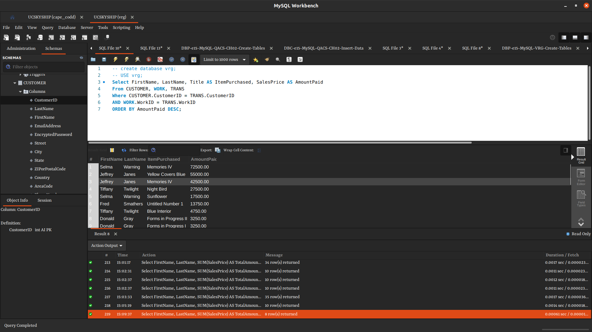

7. - create a report to show the total amount each customer spent in our store
**customer names,total amount spent

ANS:

Select FirstName, LastName, SUM(SalesPrice) AS TotalAmountSpent
From CUSTOMER, TRANS
Where TRANS.CustomerID = CUSTOMER.CustomerID
GROUP BY CUSTOMER.CustomerID;
